NESPRESSO MARKET RESEARCH PROPOSAL

1 MARCH 2024

by SEOW XIN YONG

220458971

SINGAPORE INSTITUTE OF MANAGEMENT

(1961 words)

**EXECUTIVE SUMMARY**

Nespresso is one the leading companies in the coffee industry, hence it is crucial to focus on various aspects which will affect the business. In this market research, Nespresso wants to find out an opportunity on the improvement in three distinct aspects, namely product development, customer satisfaction level, and perception on sustainability initiatives. We suggested a few research objectives to provide in-depth views and discover the patterns of the customer’s preferences and perceptions.

To carry out this market research, we selected three research designs which are exploratory, descriptive and causal research design. Online survey and online focus group discussion was conducted with consideration of the participant’s convenience. Yet, online survey is not too time consuming and easy to be conducted. Online focus group discussion emphasis on the direct interaction and reaction between group members, provides a better understanding on the consumer’s thought. Again, we used stratified sampling method to segment the participants according to their corresponding geographic region, followed by the simple random sampling method to select participants from each geographic region. The geographic regions are North America, Europe, Asia-Pacific, South America, Middle East and Africa. The sample size of participants is estimated at 81250.

For the data analysis part, we conducted cluster analysis to distinguish the different clusters of customers with different preference over the coffee blends and brewing technologies. The key finding of this analysis is there were eight clusters of customer’s preferences based on seasonal factor. To understand the difference in the mean satisfaction score between individual customers and corporate customers, the analysis of variance test (ANOVA) was carried out to test the exists of the difference in the customer’s satisfaction, where corporate customers had a higher mean score than individual customers. Subsequently, the multiple linear regression analysis was conducted to identify the factors affecting the satisfaction score, namely product quality, product packaging and customer service. These factors were then tested to determine the strength of the relationship with the customer satisfaction score, customer service was the most significant factor within the factors. The factor analysis was conducted to find out the underlying factors which were Reduce, Reuse and Recycle, from the customer perception variables.

In conclusion, further research was recommended on the marketing strategy of the sustainability initiatives done by Nespresso. This is to promote and create a positive impression of the consumers in the coffee industry on Nespresso. In general, Nespresso will be able to maintain its leading position in the coffee industry by achieving the improvements on the product development, customer satisfaction, and corporate social sustainability, and pod’s sustainability.

**TABLE OF CONTENTS**

|  |  |  |
| --- | --- | --- |
| No. | Content | Page number |
| 1 | Background | 3 |
| 2 | Challenges that are currently faced | 4 |
| 3 | Research objectives  3.1 Product Development  3.2 Customer’s satisfaction level  3.3 Corporate social responsibility | 5  5-6  6 |
| 4 | Research design  4.1 Research design  4.2 Data and scaling techniques | 7  8-9 |
| 5 | Sampling Methods  5.1 Sampling Design  5.2 Sample size | 10  10-11 |
| 6 | Data analysis  6.1 Product development  6.2 Customer’s satisfaction level  6.3 Corporate social responsibility | 12-13  13-15  15-20 |
| 7 | Timeline and Budget | 21 |
| 8 | Conclusion  8.1 Further research  8.2 Summary | 22  22 |
| 9 | References | 23-24 |
| 10 | Questionnaire | 25-35 |

**1.0 BACKGROUND**

Nespresso is an operating unit of the Nestlé Group, which is famous of its Nespresso coffee machines, coffee pods, and Nespresso coffee. The name ‘Nespresso’ is the combination of Nestlé and espresso. Nespresso comes along with the single idea which is to enable anyone to make their own perfect cup of coffee. To achieve the aim, Nespresso had invented the world’s first pre-portioned coffee system, that uses pre-apportioned packages, or recyclable capsules (pods) of grounded coffee bean, with the coffee machine to simplify the steps to make a cup of coffee. This creates conveniences for the coffee machine users to drink a cup of high quality of coffee, without the brewing skills needed.

Nespresso was started small from just a little spark of idea, until it expanded globally with the headquarter department at Lausanne, Switzerland. In 1976, Eric Favre was the inventor of Nespresso system, however it was not successful at the first ten years. After Nespresso changed its marketing, and positioned itself as a luxury brand. It gained a great success from the transformation it made, Nespresso has become one of the most influential coffee machine companies in the industry nowadays, and holds an estimation of 8.131% of market share worldwide in 2022.

**2.0 Challenges that are currently faced**

In this data-driven decision-making business environment, it is crucial to obtain as much latest information of the consumers, to grab a seat in most of the industry. Nespresso is one of the leading companies in the coffee industry, yet it is a need for Nespresso to make advancement and even changes to maintain its influence. To carry on its leading position in the coffee industry, Nespresso has determined to strengthen themselves form three perspectives, namely product innovation, customer satisfaction and corporate social responsibility.

Firstly, to develop new types of coffee flavours and explore new brewing skills, customer’s preferences towards new coffee blends and the trending brewing systems are essential as a guidance of the direction for Nespresso to work on. These findings will be the basis of Nespresso to cater all the different preferences of coffee drinkers and attract all non-customers. With these, Nespresso will be much clearer about the development of new coffee blends and brewing technologies.

Secondly, understandings about customers’ pain points towards the experience with Nespresso, in terms to improve customer’s satisfaction level. Product quality is the proportion of the invaluable features to the valueless features in a product, while packaging refers to the action of covering a product which supports movements and promotions of the products. Meanwhile, customer service is the support and a platform provided by a company to solve customer’s issues with the company’s products. A higher level of standard of these three features often comes along with a higher customer’s satisfaction level, yet these will help Nespresso to have a clearer picture of its customers’ experience, and in return improve the satisfaction level. To prolong Nespresso’s position as a leader in the industry, a high customer’s satisfaction level is crucial to maintain its position.

Besides, we are aware of the perceptions and awareness of the consumers in the coffee industry towards the sustainability of its capability and the chance for enhancement. In aids to create a positive impression of the sustainability of its reusable capsules (pods) to its customers, it will be better for Nespresso to be more conscious of the industry environment and public focus on the corporate social responsibility. Moreover, an effective dissemination of Nespresso’s effort on the sustainability of the pods will ensure more exposures for the customers to obtain information.

To conclude, Nespresso wants to take actions to leverage its products, improve its customer’s satisfaction level, and further enhance the perception of the customers towards the sustainability of its pods. As an assistance of the actions, knowledge is one of the most important clues which Nespresso should obtain.

**3.0 Research objectives**

In general, Nespresso wants to enhance their products and services in terms of product innovation, customer’s satisfaction level, and corporate social responsibility. To achieve the three forms of improvements, a few more detailed and specified research objectives (ROs) should be determined for these perspectives.

**3.1 Product Development**

RO1.1: Determine the existing coffee blends and trending brewing technologies.

RO1.2: Identify the seasonal preferences of the consumers over the new coffee blends and brewing technologies.

The research objective provides a clear insight of the consumers’ preferences in the coffee industry, by specifying consumers’ preferences into seasons. A before-hand research on the existing new coffee blends and brewing techniques, will be useful to develop new products which satisfies the needs of consumers. Besides, the division of consumers based on general profile is vital for a multinational company, such as Nespresso. This enables Nespresso to target different segments of consumers more effective and efficient. By clustering the consumers based on their status, the trend and taste among coffee drinkers according to distinct will be more transparent.

**3.2 Customer’s Satisfaction Level**

RO2.1: Determine the difference in the average score of overall satisfaction between corporate and individual customer.

RO2.2: Identify the significant factors which associated in customer’s satisfaction and the extent of influence of each factor.

From the client brief, we will propose to focus on three main areas of factors, namely, product quality, product packaging and customer service. Factors which contribute to the customer’s enjoyment comes from these three areas. A complete understanding on the products and services of Nespresso will provide useful information for further improvements. The effect of each factor on customer’s satisfaction will be observed in details from different views. With these observations, the level of influence of each factor on the customer’s satisfaction can be extracted from the explicit information. From here, Nespresso will have a better clue on the level of significance for each factor, yet it is easier to distribute their effort for improvement on each factor accordingly. Since corporate customers satisfaction have a completely different structure than individual customers satisfaction, hence it is worth to explore the components which build up both corporate and individual customers satisfaction. To better deliver and provide services to different types of customers, it is indeed needed to discover the overall satisfaction of corporate customers and individual customers.

**3.3 Corporate Social Responsibility**

RO3.1: Identify the relationship between the age group of the participants and the perception score on the sustainability initiatives of Nespresso.

RO3.2: Determine the types of common patterns on the responsibility initiatives and the pod’s sustainability of Nespresso.

The public concern on the sustainability of the reusable capsules is being aware by Nespresso. Provided Nespresso has launched an AAA Sustainability Quality Program, in aids to support the development of the pods’ recycling scheme. A clear picture on customer’s thoughts on the sustainability initiatives of Nespresso pods supports Nespresso to enhance their current effort, in terms of whether the promotion of responsibility activities, or the room for improvement of the initiatives.

**4.0 Research Design**

**4.1 Research Design**

Considering to obtain the data and information of the consumers in the coffee industry, we will have to determine suitable research designs and methods for this research. In this market research, most of the information comes from the ideas and perception of the consumers in coffee industry, hence we will carry out three types of research designs, which are exploratory, causal and descriptive research design.

Firstly, Exploratory design enables us to brainstorm the ideas and questions which provide depth and clarity on the research aims and research objectives. The qualitative research method included in exploratory design offers two types of approaches, in aids to collect customer’s immediate feedback and reaction on the question asked to them. These research methods could be useful to exploratory, instead of the conclusion on the consumer’s thoughts.

Meanwhile, descriptive design provides a clearer understanding on the current circumstances which Nespresso faced. The consumer’s behaviour, and the trend of the occurred events will be observed and recorded to extract useful data. Causal design helps to explain the relationship the factors and effects which are appropriate for this research. We will be using online focus group and online survey to complete the research design. Given the six-month timeframe to complete the research, we suggest to use the two approaches which are both timely and cost-saving. It is easier to collect data online, yet consumers will be more convenient to answer the questions in a focus group discussion and an online survey. The observation methods such as personal observation, electronic observation, audit and trace analysis are not recommended for this market research. This is because of the extremely long duration of time needed for observation and too costly.

In this research, there will be two types of data involved, namely Primary data and Secondary data. Primary data refers to data which are collected and carried out by ourselves, while secondary data are those existing data related to the research aims.

**4.2 Data and scaling techniques**

**4.2.1 Primary Data**



Table 4.2.1: The variables of primary data and types of primary data.

**4.2.2 Secondary Data**



Table 4.2.2: Variables of secondary data and the types of secondary data.

**5.0 Sampling Methods**

**5.1 Sampling Design**

To complete a sampling design, we should define on the target population of this market research, which is all the coffee drinkers around the world. Since the given time frame is too short and it is too costly to investigate on the whole population, hence we propose to use a sample for this market research. The sampling is the list of email address of the customers who have purchased items from any company in the coffee industry. Here, we could access the database provided by Nespresso and extra assess to other’s company’s database to obtain the email addresses.

Firstly, we suggest to use Stratified sampling to stratify the target population into different types of geographic region. This sampling method will help in improve the precision of the result and more time-saving. Judgemental sampling method was taken into the considerations, however it is too subjective and hard to generalise the data. According to the segmentation of Nespresso capsules market, we divide the target population into six strata, namely, North America, Europe, Asia-Pacific, South America, Middle East and Africa. Subsequently, we propose to use simple random sampling method (SRS) to select the participants for the survey randomly, from these regions. These will help to prevent the biasness of the data information which will affect to the result of this market research.

For the sampling techniques, we recommend to use online focus group discussion formed by 6-10 persons per group, which is chosen from the participants of the sample. Two moderators will be included in each group to encourage the express of ideas and thoughts from group members. While the online survey and online focus group will be conducted in different languages and different time according to different geographic zones the participant is from. This could increase the willingness of the participants to answer the survey questions and more convenient for the participants. Moreover, the insights gained from the data will help to detect the pattern and trend of the data. The survey questions which could be useful to achieve the research objectives will be asked in the questionnaire.

**5.2 Sample size**

We are interested in the proportion of participants who meet the criteria of the survey and will participate in the online survey. We will assume the proportion at 60%.

In aids to determine the sample size for this market research, we will separate the customers and non-customers of Nespresso in the calculation steps. For both calculations, we will be using the formula below:

Where n is the size of participants selected. We estimate the confidence interval at 95% level, the precision level, e is assumed to be ±0.05 within the real population proportion.

We set the completion rate at 33% as a benchmark, according to the average response rate of online survey. The incidence rate is the percentage of participant who meet the criteria of the survey, and it is estimated to be 90% in this market research. The final size of participants selected will be adjusted using the formula below:

From the client brief, the minimum requirement of the sample size of customers should be at least 5000. Moreover, the final sample size of customers and non-customers will be adjusted by the market share accordingly. Hence, the final sample size of customers is 6500, while non-customers will be 74750.

**6.0 Data Analysis**

We will carry out data cleaning by cancelling out duplicate records, missing of data, inconsistent format of data, etc., before the process of data analysis.

**6.1 Product Development**

**RO1.1: Determine the existing coffee blends and trending brewing technologies.**

The discussion on the current coffee blends and brewing skills will be conducted in an online focus group. A moderator will start the discussion by introducing his identity and the basic information of the discussion. An “icebreaker” activity will be carried out followed the introduction to enliven the communication between group members. The moderator will slowly lead the conversation to the topic of the discussion by asking some questions with open-end answer. Another moderator will record the whole conversation and ensure the accuracy of the insight extracted from the discussion.

This focus group discussion helps to get information about the trending coffee blends and brewing skills by asking questions to the current coffee consumers directly. The information obtained from this discussion will be one of the foundations for the following analysis techniques.

**RO1.2: Identify the seasonal preferences of the consumers over the new coffee blends and brewing technologies.**



Table 6.1.2: The variables of cluster analysis.

Cluster analysis will be conducted to segment the consumers according to their seasonal preferences on the new coffee blends and brewing skills. We will first select the variables based on past research, as shown in table 6.1.2. Since the variables are categorical, we will use the agglomerative hierarchical technique, namely Ward’s method to minimize the variation within each cluster. In this method, we will sum up the squared Euclidean distance between the objects and cluster mean in each cluster, and combine the two clusters which have the smallest sum. We estimate to have eight clusters by using Dendrogram, to identify the larger distance between clusters of previous stage and next stage.

**6.2 Customer’s Satisfaction Level**

**RO2.1: Determine the difference in the average score of overall satisfaction level between corporate and individual customer**



Table 6.2.1: Null hypothesis, alternative hypothesis, independent variable and dependent variable of ANOVA.

This is a one-way ANOVA test which involves one metric dependent variable and one categorical independent variable. To carry out the F-test, we will use the formula below to calculate test statistic:



We will calculate the eta-square, η2 which indicates the effect of X on Y, using the formula below:

where SSy = sum of squares of the variation in Y.

Next, we complete the ANOVA table.

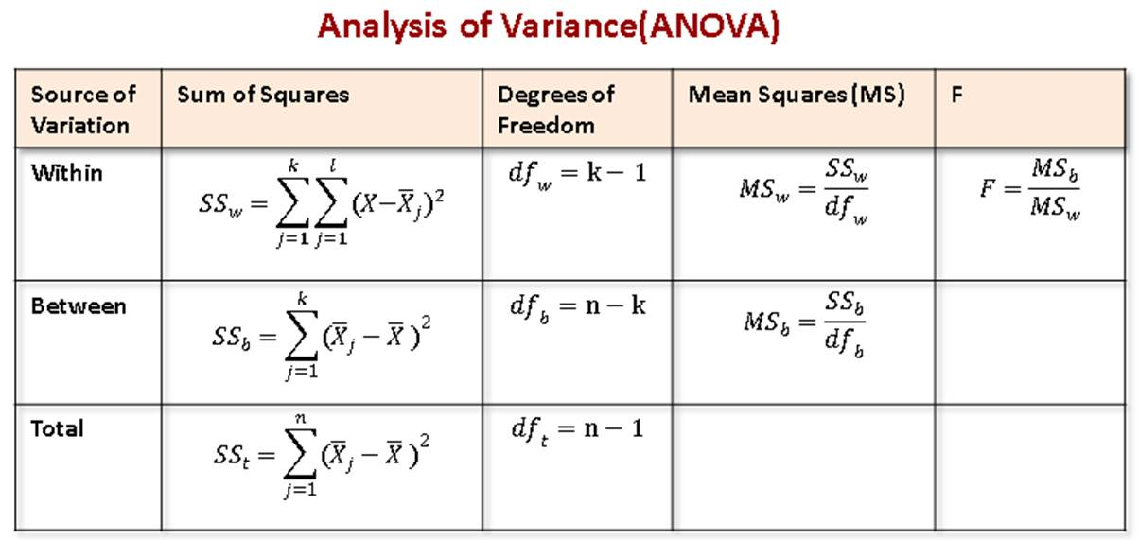

Source: ANOVA table from: <https://kindsonthegenius.com/blog/one-way-anovaanalysis-of-variance-problem-question-11/>

For the p-value, we will use SPSS Statistic to estimate the value. If p-value > 0.05, indicates that the test statistic is not significant, there is no difference in the average customer satisfaction score between corporate and individual customer. Hence, we will not reject the null hypothesis. If p-value < 0.05, infers to the opposite situation, the null hypothesis will be rejected. When the value of eta-square < 0.01, the effect of X on Y will be negligible even if p-value < 0.05. When the test is significant, we will carry out Post-hoc test to determine the significant group.

**RO2.2: Identify the significant factors which associated in customer’s satisfaction and the extent of influence of each factor.**

We advise on using multiple linear regression techniques to analyse the factors affecting the customer’s satisfaction level, and determine the strength of the relationship.



Table 6.2.2: The independent variables, dependent variable, and assumptions

We will plot the scatter diagram of the factors affecting the customer satisfaction score (X) and the customer satisfaction score (Y), to check the exists of a relationship between factors and customer satisfaction. From here, we will form a linear regression model:



In aids to measure the strength of association in this model, we suggest to use the coefficient of multiple determination, formula for calculation:



To test the significance of the overall regression, we will use F-test to carry out. While for each partial regression coefficient, we will carry out individual t-test.

**6.3 Corporate social responsibility**

**RO3.1: Identify the relationship between the age group of the participants and the perception score on the sustainability initiatives of Nespresso.**



Table 6.3.1: The null hypothesis, alternative hypothesis, independent variable, and dependent variable

We will carry out F-test on this relationship. If the test result is significant, we will then conduct Post-hoc test to determine the significant group.

**RO3.2: Determine the types of common patterns on the responsibility initiatives and the pod’s sustainability of Nespresso.**

We will start off factor analysis by checking the appropriateness of the analysis to analyse this relationship by using correlation matrix, KMO statistic, Barlett’s test of sphericity and Communalities table:



Table 6.3.2: The labels of the variables



Figure 6.3.2: Correlation matrix

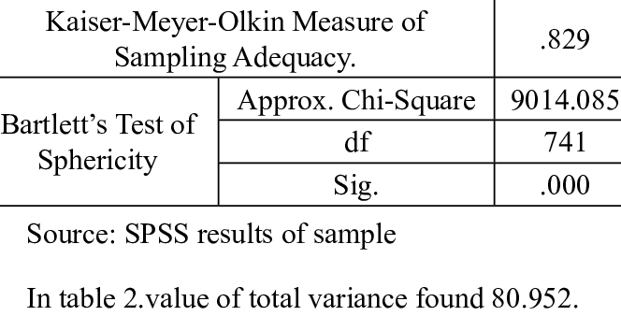

Figure 6.3.3: Example of table of KMO statistic and Barlett’s test of sphericity from: <https://www.researchgate.net/figure/KMO-and-Bartletts-Test-Value-of-Kaiser-Meyer-Olkin-in-table-1-is-0829-bartletts_tbl1_334395580>

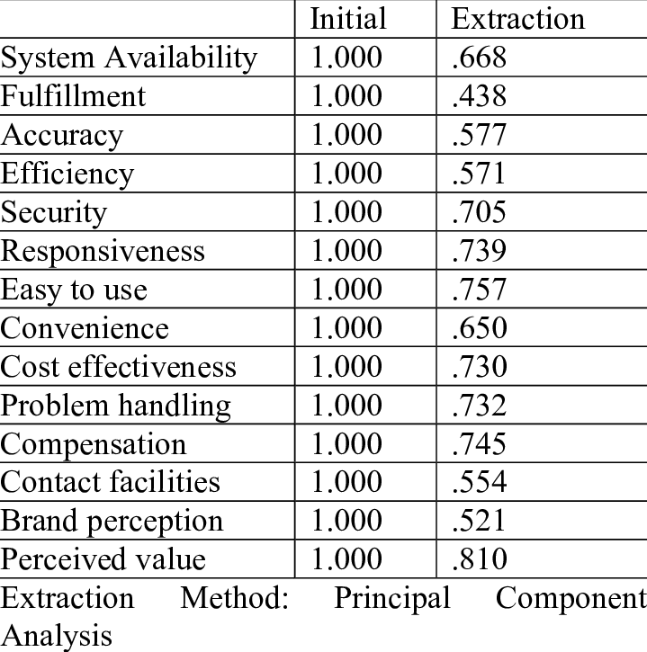

Figure 6.3.4: Example of Communalities table from: <https://www.researchgate.net/figure/Table-showing-the-Communalities_tbl5_359894532>

We will carry on the analysis of data by using principal component analysis to determine the minimum number of underlying factors. In here, we will use these criteria, factors with eigenvalue > 1, and the number of points just before the scree begins to filter out the number of factors. Hence, we rotate the factor matrix with the varimax procedure of orthogonal rotation. Besides, we interpret the factors by using Rotated Component Matrix and Factors Loading Plot. We will estimate the factor score for each factor with the Component Score Coefficient Matrix, generated by SPSS.

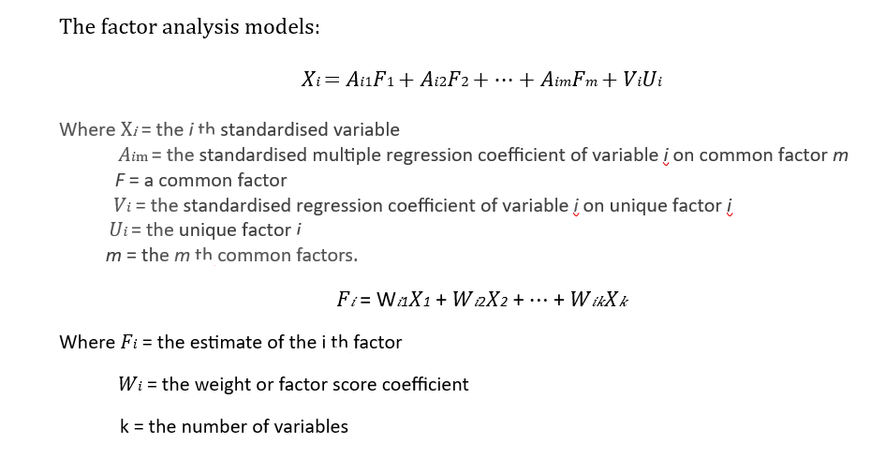

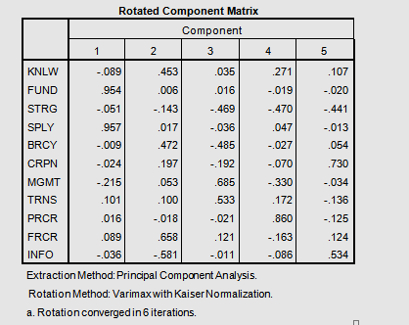

Figure 6.3.5: Example of Rotated Component Matrix from: <https://www.researchgate.net/figure/SPSS-output-for-Rotated-Component-Matrix-On-the-basis-of-rotated-component-matrix-various_fig2_280788523>

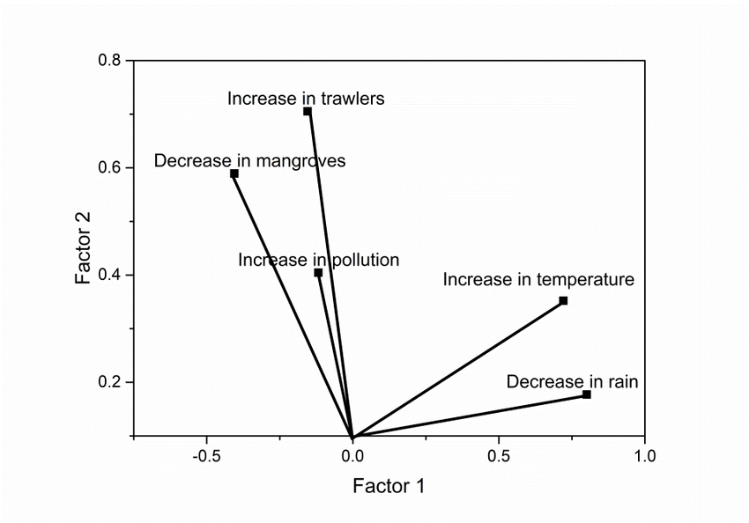

Figure 6.3.6: Example of Factors loading plot from: <https://www.researchgate.net/figure/Plot-of-the-factor-loadings_fig3_327322035>

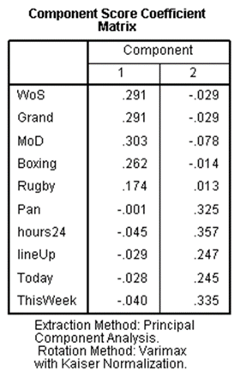

Figure 6.3.7: Example of Component Score Coefficient Matrix from: <https://docs.displayr.com/wiki/Component_Score_Coefficient_Matrix>

Next, we propose to use SPSS to generate values in the Reproduced Correlations table. We can conclude that residuals with coefficient > 0.05, is the significant variables affect the perception of consumer on the sustainability initiatives of Nespresso and the sustainability of pods.

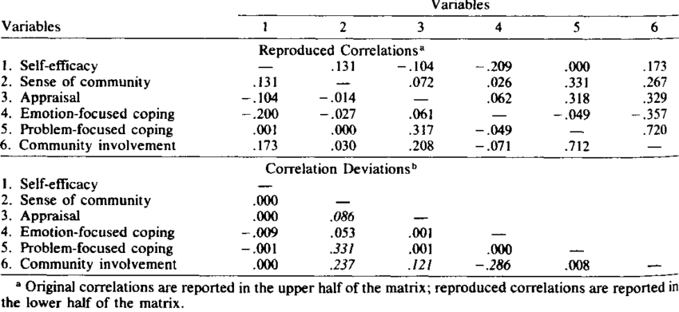

Figure 6.3.8: Example of Reproduced Correlation Table: <https://www.researchgate.net/figure/Reproduced-Correlations-and-Correlation-Deviations-of-Proposed-Path-Model-for-Total_tbl2_19131379>

Finally, we will name the factors appropriately.

**7.0 Timeline and Budget**



**8.0 Conclusion**

**8.1 Further research**

In this market research, we will suggest to have a longitudinal study to be aware of the patterns and trends of the preference of customers and perception on sustainability initiatives of Nespresso over time. This could be useful to analyse the factors affecting the preference of customers and perception, hence it will provide insights for Nespresso to further strengthen their weaknesses. However, this study is too time-consuming, a sufficient duration of time is crucial for this study.

Moreover, an effective and productive marketing strategy will create a positive impression to the consumers in the industry. Yet, the consumers will have more access to obtain information of Nespresso. Thus, we advise Nespresso to put more attention on the marketing strategy of their products and services.

**8.2 Summary**

In conclusion, this market research could be useful to make improvements on the product development, customer satisfaction and perception on pod’s sustainability. The findings from the data analysis will help in achieve the research aims and even a more complete data interpretation for Nespresso. Nespresso will be able to maintain its leading position in the coffee industry and see a growth of sales profit in this competitive market.

Meanwhile, Nespresso will be able to refine their current business strategy based on the useful observations in the data analysis. Nespresso will have a clearer picture and direction where they shall put their effort into.

*-End of Research-*

Total word count: 2961 words

(Excluding tables, figures, labels, and references)

**9.0 REFERENCE**

1. *OUR STORY | Nestlé Nespresso*. (n.d.). <https://nestle-nespresso.com/about_us/story>
2. Wikipedia contributors. (2024, February 4). *Nespresso*. Wikipedia. <https://en.wikipedia.org/wiki/Nespresso>
3. Khan, A. (2023, September 5). *What is Nespresso? All About Nespresso*. Coffee Aim. <https://coffeeaim.com/what-is-nespresso/>
4. Pahwa, A. (2023, February 21). *What is packaging? – definition, types, & functions*. Feedough. <https://www.feedough.com/packaging-definition-types-functions/>
5. Onehour. (2017, March 2). *CHECKLIST: What information to include in your customer database - One Hour Marketing*. One Hour Marketing. <https://onehourmarketing.com/customer-database-1/>
6. S, S. (2022, July 14). *Difference between Probability and Non-Probability Sampling (With comparison Chart) - Key differences*. Key Differences. <https://keydifferences.com/difference-between-probability-and-non-probability-sampling.html>
7. Villegas, F. (2023, August 10). *Sampling Frame: Definition, Examples & How to use it*. QuestionPro. <https://www.questionpro.com/blog/sampling-frame/>
8. MacDonnell, K. (2023, October 5). *37 Coffee Statistics in 2024: Fascinating Facts (With infographics)*. Coffee Affection. <https://coffeeaffection.com/coffee-statistics/>
9. *Yahoo is part of the Yahoo family of brands*. (n.d.). <https://finance.yahoo.com/news/nespresso-capsules-market-size-2023-101100235.html?fr=sycsrp_catchall>
10. Statista. (2023, October 20). *Revenue of the coffee industry worldwide 2018-2028*. <https://www.statista.com/forecasts/1419714/global-coffee-industry-revenue>
11. Chung, L. (2023, September 22). *What is a good survey response rate for customer surveys in 2022?* Delighted. <https://delighted.com/blog/average-survey-response-rate>
12. *TABLE 2 . Reproduced Correlations and Correlation Deviations of. . .* (n.d.). ResearchGate. <https://www.researchgate.net/figure/Reproduced-Correlations-and-Correlation-Deviations-of-Proposed-Path-Model-for-Total_tbl2_19131379>
13. *Component Score Coefficient Matrix - Displayr*. (n.d.). <https://docs.displayr.com/wiki/Component_Score_Coefficient_Matrix>
14. *Figure 3: Plot of the factor loadings*. (n.d.). ResearchGate. <https://www.researchgate.net/figure/Plot-of-the-factor-loadings_fig3_327322035>
15. *KMO and Bartlett’s Test: Value of Kaiser-Meyer- Olkin, in table 1 is. . .* (n.d.). ResearchGate. <https://www.researchgate.net/figure/KMO-and-Bartletts-Test-Value-of-Kaiser-Meyer-Olkin-in-table-1-is-0829-bartletts_tbl1_334395580>
16. *One-Way ANOVA (Analysis of Variance) problem - Question 11 - The Genius Blog*. (2020, November 5). The Genius Blog. <https://kindsonthegenius.com/blog/one-way-anovaanalysis-of-variance-problem-question-11/>

**10.0 Questionnaire**

